Solution structure

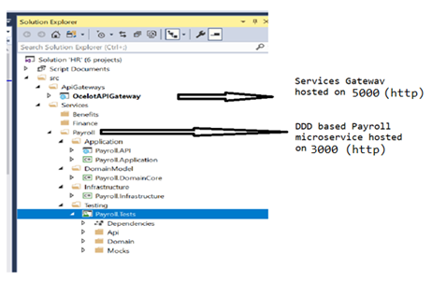

Unit tests:

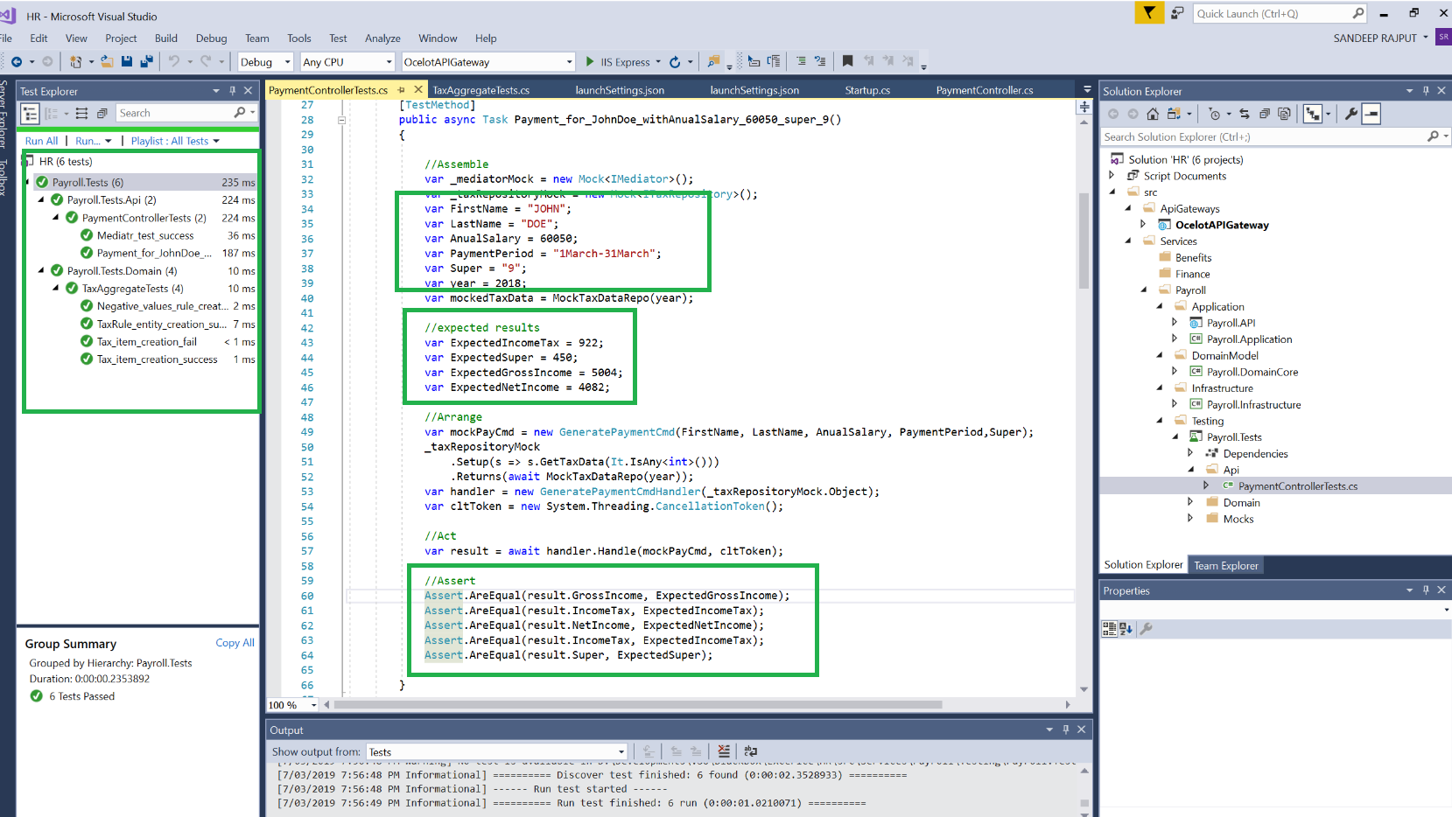

In order to launch follow any of the below options:

1. Using CMD, go to path of .proj, type – dotnet run and press enter. Start in below order:
2. Start PayRoll.API first
3. Start OcelotAPIGateway

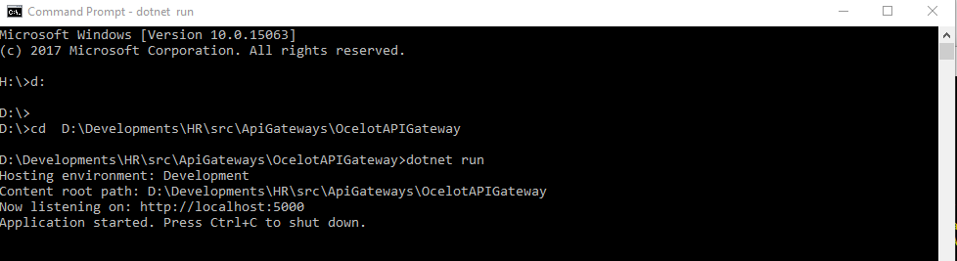

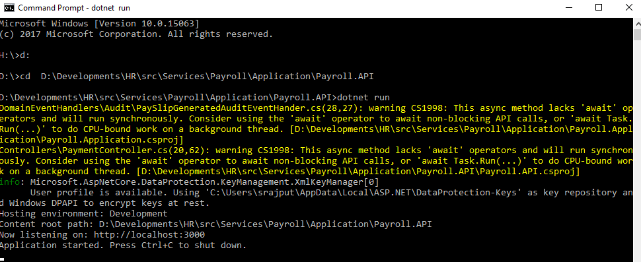

1. IIS Express: Right click project in Visual studio – Debug – Start New Instance

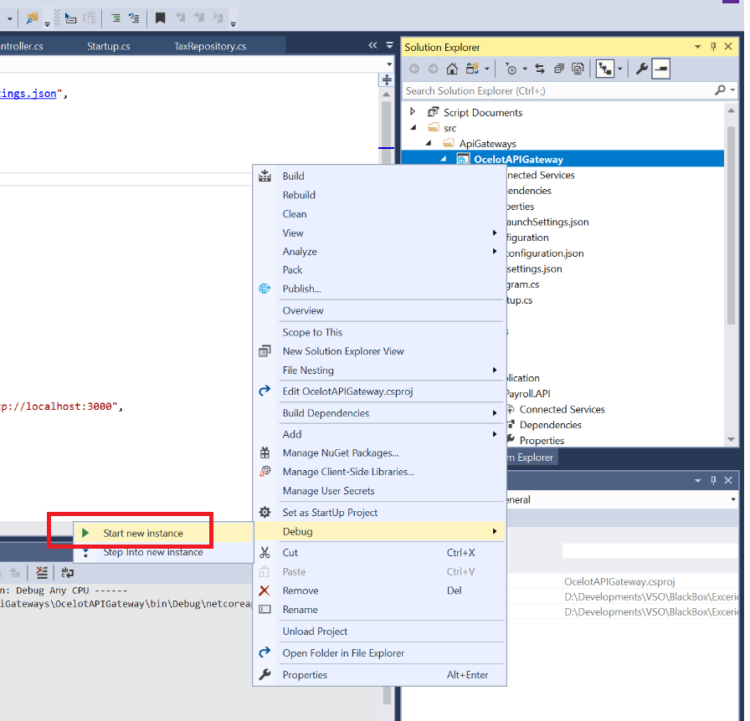

After the services are launches and running, see it in action:

Browse to the gateway address: <http://localhost:5000/swagger> and consume/test the payroll functions:

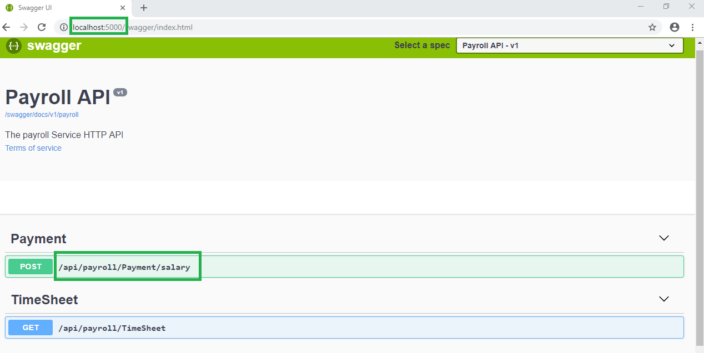

You can test the service by making a direct call to the webapi without going through the gateway.

Browse the service address: <http://localhost:3000/swagger> and test the payroll functions via swagger.

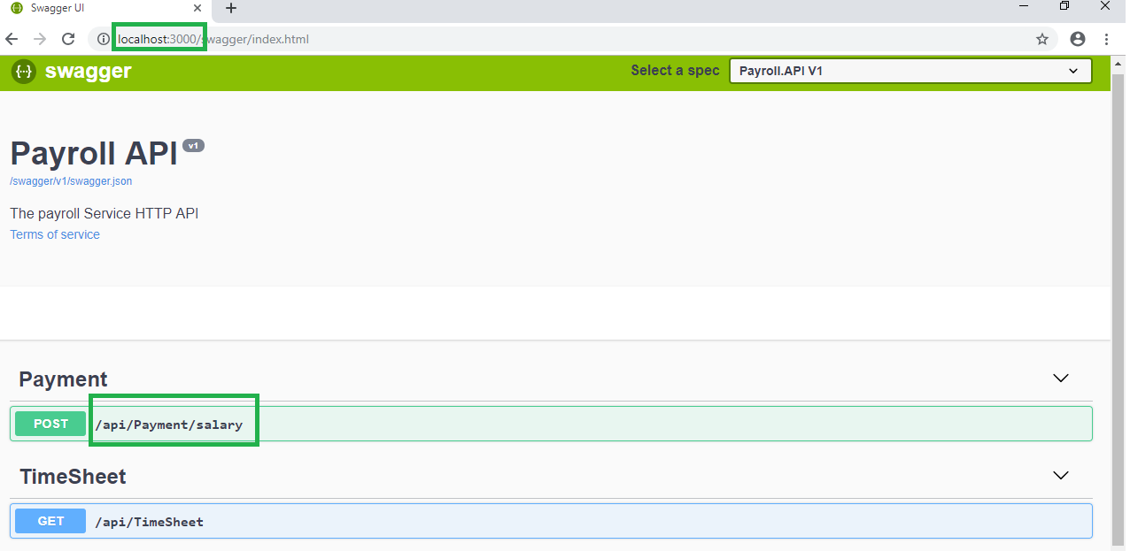

1. Swagger results via gateway testing:

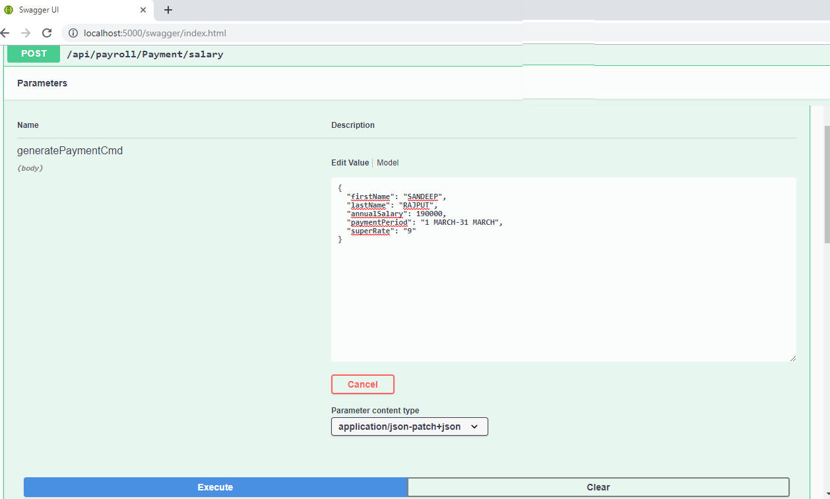

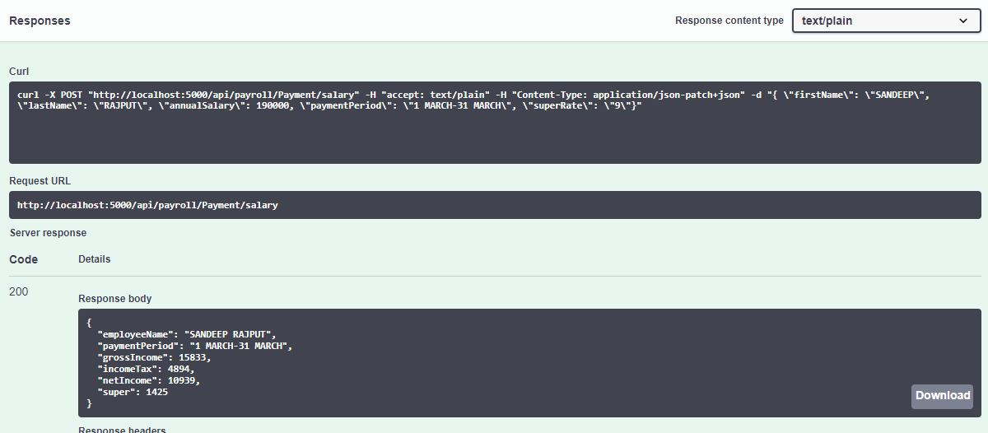

Swagger results for testing via API direct

